Positive Behavior Intervention and Support (PBIS)

Dixon Montessori School-Wide Management Plan
- Teacher Checklist
- School Management Plan
- Behavior Log
- Think Slip Flow Chart with Pictures
- Think Slip Flow Chart
- Think Slip Flow Chart with sentence starters
- Parent Letter
- Giving an official Warning
- Giving a Directive (how to move to the next step)
- How to give a referral
- Project Wisdom and Social Skills
- MERIT Rallies
- Kickboard

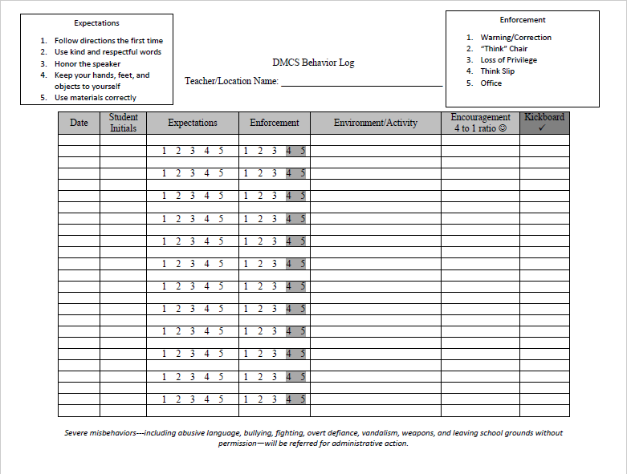

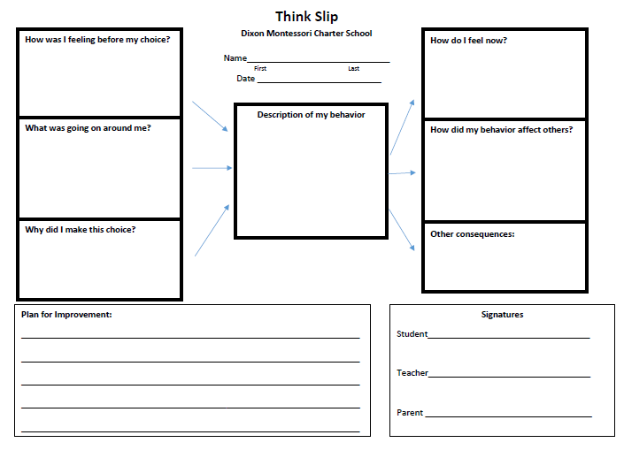

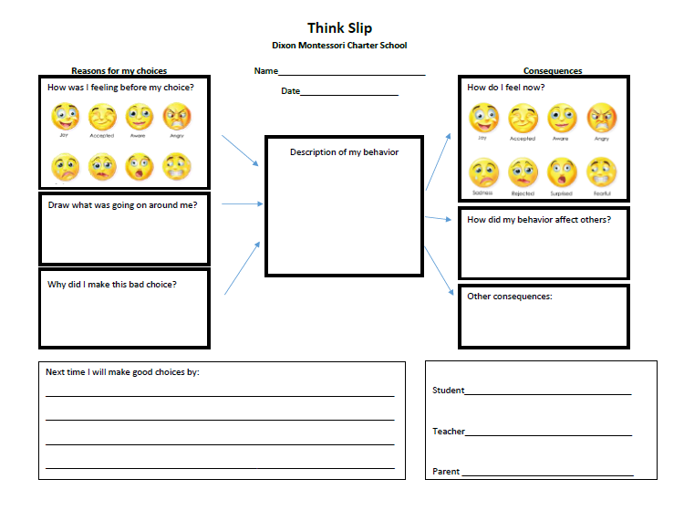

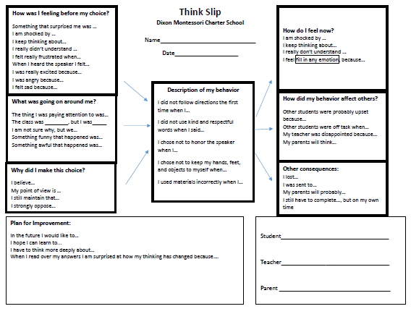

Dixon Montessori Charter School
Referral Procedure

Step 5 or Severe Misbehavior- including fighting, vandalism, intoxicants, and leaving school grounds without permission.
- Open Kickboard
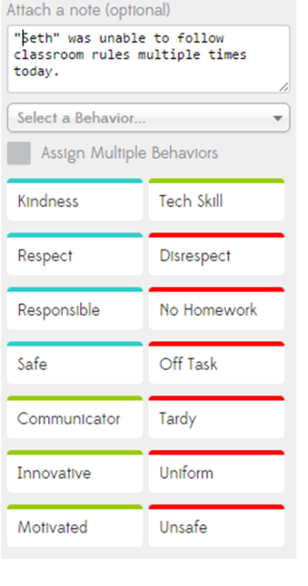
- Select the student

Write a brief explanation of what happened
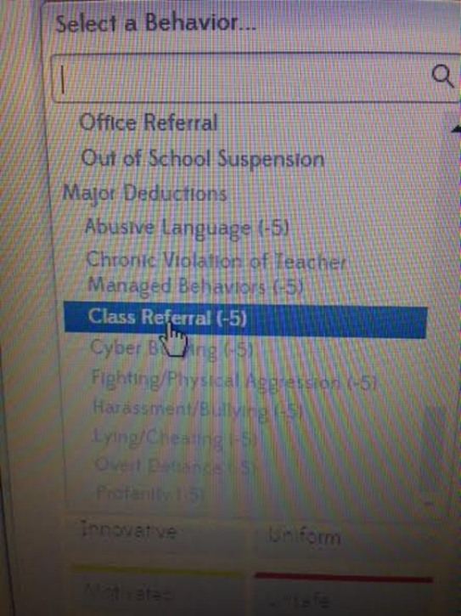
- Open the “Select a Behavior” scroll bar
Select Class Referral

- The administration team will be notified via text message, and will be there shortly

Project Wisdom and Dixon Montessori
Project Wisdom is the school-wide social skills and instruction program used by DMCS. The centerpiece of the Project Wisdom program is a collection of thought-provoking messages designed to be read over the PA, or in class, that encourage everyone on campus to use social skills daily.
Dixon Montessori uses an online library of Daily Messages on the Dean of Students web page: http://dixonmontessorideanofstudents.weebly.com/project-wisdom.html
- Teachers are expected to read Project Wisdom’s "Words of Wisdom," daily messages every morning after the Pledge of Allegiance and the MERIT Pledge.
- Monthly themes like “Respect” and “Kindness” will be introduced at MERIT Rallies, and will be encouraged with “Words of Wisdom” and Kickboard points.
To access daily messages teachers will need to follow these steps:
- Go to the Dixon Montessori website
- Hover over the “Our School” header tab
- Scroll down the “Our School” tab and
  - Click on “Teacher Sites”
- Click on “Benjamin Ernest” to access the Dean of Students site
- At the top left corner there is a menu tab
  - Click the menu tab
  - Scroll down to “Teacher Resources”
  - Click “Teacher Resources”
- Scroll down to “Project Wisdom”
  - Click “Project Wisdom”
  - Scroll down to see monthly messages
  - Click to download
  - Or save this site to your device
http://dixonmontessorideanofstudents.weebly.com/project-wisdom.html

2017-18 MERIT Schedule
Month | MERIT RALLY  DATE | Character Trait  Monthly Theme | Grade Level  5-min “presentation”
August | August 11 | Off to a Good Start: Expectations
September | September 29 | Responsibility | K/1
October | October 26 | Respect | 2/3
November |  | Gratitude
December | December 15 | Hard work  & Determination | 4/5
January | January 29 | Kindness  (GKC Jan 22-26) | K/1
February | February 25 | Honesty | 2/3
March | March 25 | Confidence | M/S
April | April 22 | Citizenship  & Cooperation | 4/5
May | May 27 | Self-respect  & Self-discipline | ALL  Leadership

Regular Day Schedule: K-3 1:40-2:00 --- 4-8 2:10-2:30
Minimum Day: Whole School 11:30-12:00
- Mr. Ernest – Welcome! 1 minute
- Grade Level – Character presentation 5 minutes
- Grade level “Character Trait” awards (2-3 students per class) 5 minutes
- Leadership – M.E.R.I.T / New Character Trait activity/Game 5 minutes
- “I saw you being….” 10 names drawn for MERIT pizza day 5 minutes
MERIT Rally Procedures and Expectations

The purpose of MERIT Rallies is: To recognize strong character traits displayed by Montessori students, to introduce monthly character themes, and to build positive culture at DMCS.

Procedures
  - MERIT Rallies occur at the end of each month and take approximately 20-30 minutes
  - Arrive to the MPR promptly at the start time
  - Leadership students will help your class to their areas on floor
    - Make sure there is walking space between classes for teachers
  - Teachers stand or sit at the sides of the MPR near their classes
  - Mr. Ernest and the Leadership Team will run the rally
  - Students will be called up to receive awards, take pictures, play a game, or otherwise participate in the rally
  - Classes are dismissed when the rally is over
Expectations
  - This is a celebration of character. Students will be excited and may act accordingly, but must follow all school expectations by remaining safe, responsible, and respectful.

School Expectations
    - Follow directions the first time
    - Use kind and respectful words
    - Honor the speaker
    - Keep hands, feet, and objects to themselves
    - Use materials correctly

  - When there is a call to attention students use SLANT (taught at the first MERIT Rally)
  - Teachers must manage their students, and other students, during the rally
  - Teachers follow an adapted Enforcement Plan

Rally Enforcement Procedure
    - Teacher touches the student on the shoulder and says, “This is your warning”
    - Teacher moves the student to the side of the MPR
    - Teacher sends the student to the office
*Teachers may bypass steps 1 and 2 if there is a need for a referral

