Dixon Montessori Charter School
Official Warning

Show you have MERIT by being
Respectful, Responsible, and Safe!

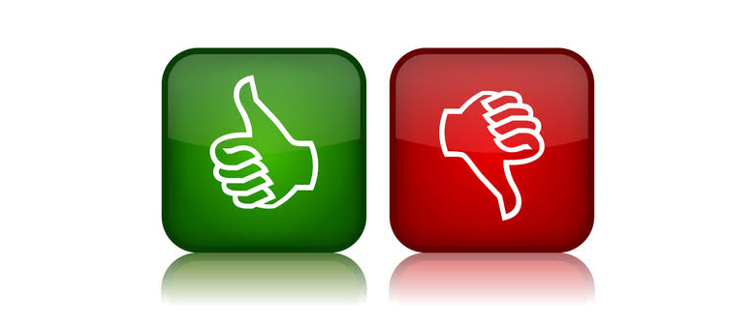
Always use a professional, proactive tone

- Name the behavior violation

- State the behavior expectation

- Explain the reason for the rule, or model the expectation

- Say “Try again” and/or “Next Time”

- That’s your warning…Walk to the clipboard/behavior log

SAMPLE
“Ben and Chris, that’s excessive noise during silent reading. Excessive noise is not respectful because it deprives us all of having a quiet time to concentrate. Next time you need to respect the study time of others by staying silent… That’s your warning.”
“That is exaggerating, Jezebel. Exaggerating is inappropriate in our classroom because it creates a distorted view of the situation. Try again, give me an accurate account of the incident. Next time be more accurate. Thank you.”
“Lara, you were running in the hall. Running in the hall is unsafe and is not responsible. Go back and try again. Next time walk, that’s your warning.”
“Andrew, that’s what we call gossip. Gossip is not a helpful behavior because we do not know if it is true, and it might be hurtful to someone. Next time please wait until Walter is present and ask him directly about what you heard. That’s your warning.”
“Sarah, that’s a put-down. Put-downs are not respectful. We don’t use them because they often hurt peoples’ feelings. Apologize now. Next time use kind words. That’s your warning.”
“April, that’s whining, and whining doesn’t work with me because it hurts my ears and I can’t tell what you want. What works with me is to ask in a normal voice, sometimes you get it, sometimes you don’t. Try again. Thank you.”
If you have had this conversations multiple times jump straight to modeling the appropriate behavior
When a student gives an excuse say, low and slow, “Yes Ms. Robin.” (Wait for them to repeat) “That’s your warning”
“Try again Courtney, start at that line in the hallway” (Wait for them to walk appropriately) “That’s your warning”

