Culture Reference Guide

BASICS
Your School’s Kickboard Website  dmcs.kickboardforteachers.com  Logging In  Username: first initial + last name  Example: Suzy Jones would be sjones  Set Password: Click the “Forgot your password?” link to create your unique password. | 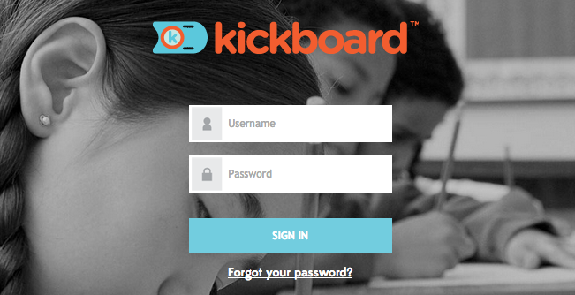
Adding Yourself to Groups  - Go to Students Groups  - Find the student group you need  - Hover over the orange action cog  - Click + Add me to Group | 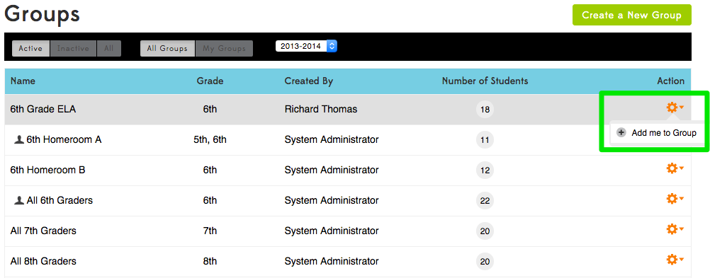
Creating New Groups  - Go to Students Groups  - Click Create a New Group  - Under Group Info name the group & select the grade level(s) of students in the group  - Under Students expand the grade list and select the students in the group  - Click Create New Group | 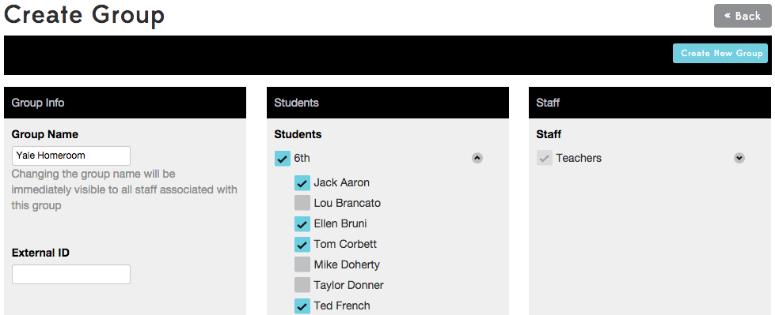

CULTURE DATA ENTRY
Entering Behaviors  - Go to Culture Daily Activity  - Choose the student Group  - Select a student (or multiple students)  - (Optional) Type a note  - Select a behavior from the dropdown list or select a behavior quick button | 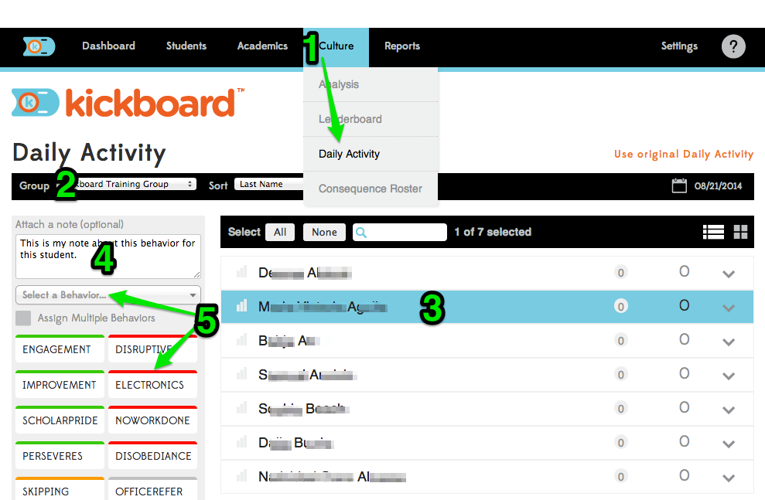
Daily Activity Page Tips  - Select multiple students by clicking on multiple rows  - Select the whole group at once by clicking the “All” button  - A count of how many students are selected will appear in the small black banner  - To search for a student, start typing the name in search box with the magnifying glass icon  - Assign multiple behaviors at once by selecting a student, checking Assign Multiple Behaviors, choosing multiple quick buttons, then clicking Assign Behaviors  - To switch between list view and card view, click the row or window icons | 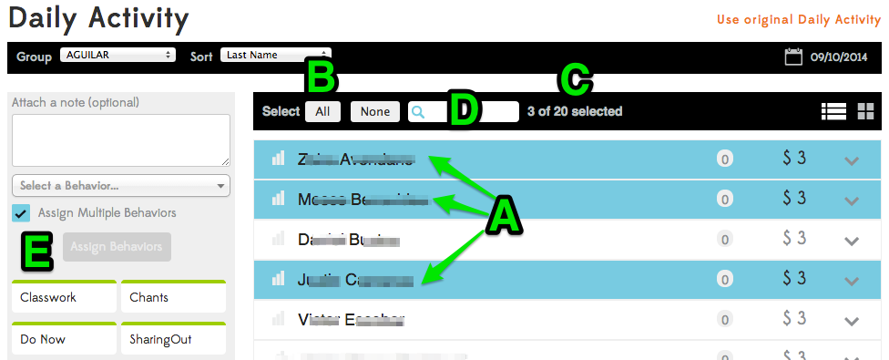  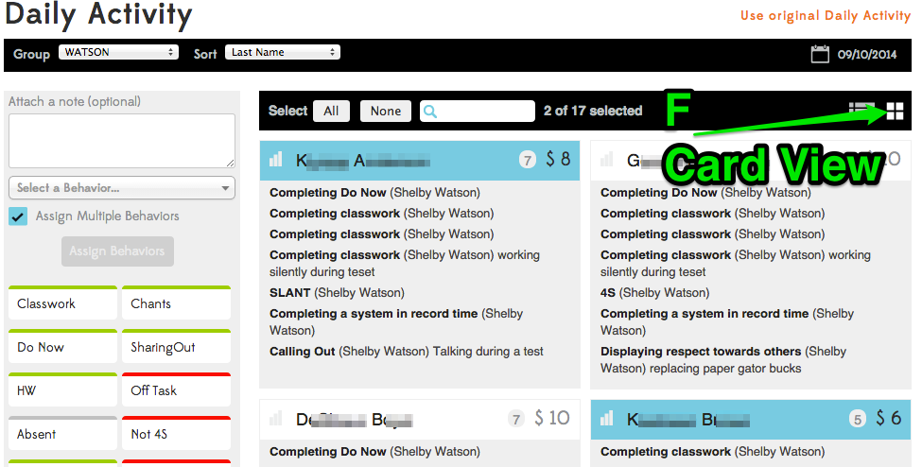

CULTURE ANALYSIS
Dashboard School  The Schoolwide Dashboard defaults to showing data for the current week, but you can change the date range by clicking on the calendar icon.  Hovering over any parts of the graphs will show you more details. | 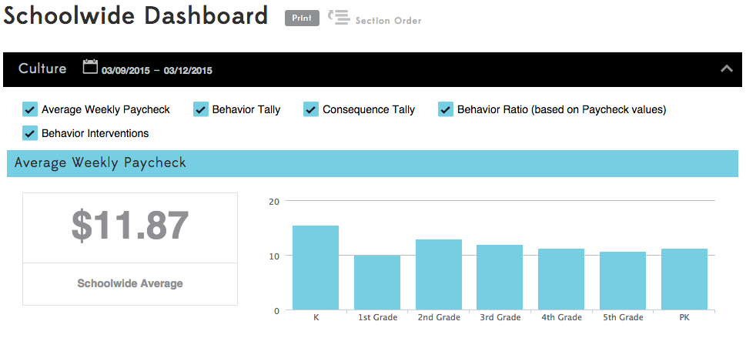  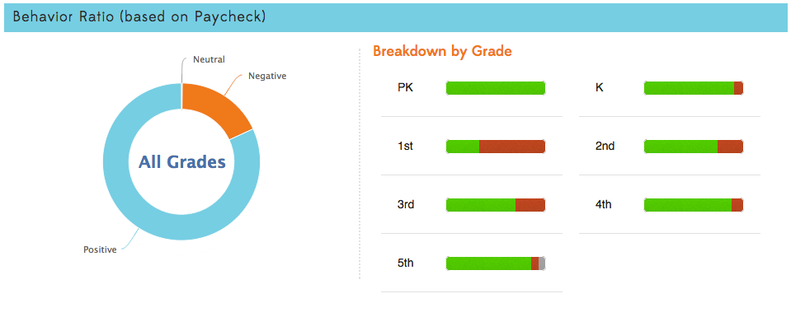
Culture Leaderboard  The leaderboard will list students in order of their daily or weekly averages or total point balance.  You can change the date range and metric, and you can filter down to a particular group. | 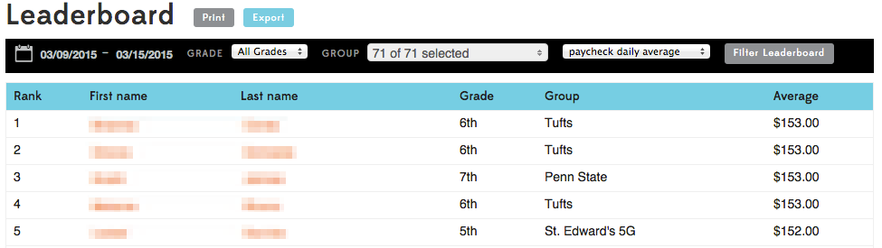
Culture Analysis  Choose how you want the data displayed:  - School- compare grade levels  - Groups- Compare student groups within grade levels  - Teachers- Compare teachers within grade levels  - Student- Drill down to a single student  Filter the data to drill down even more:  - Behaviors- select a specific behavior, a whole category of behaviors, or a combination of any behaviors.  - Date Range- defaults to whole school year, but can be narrowed by clicking on the calendar. | 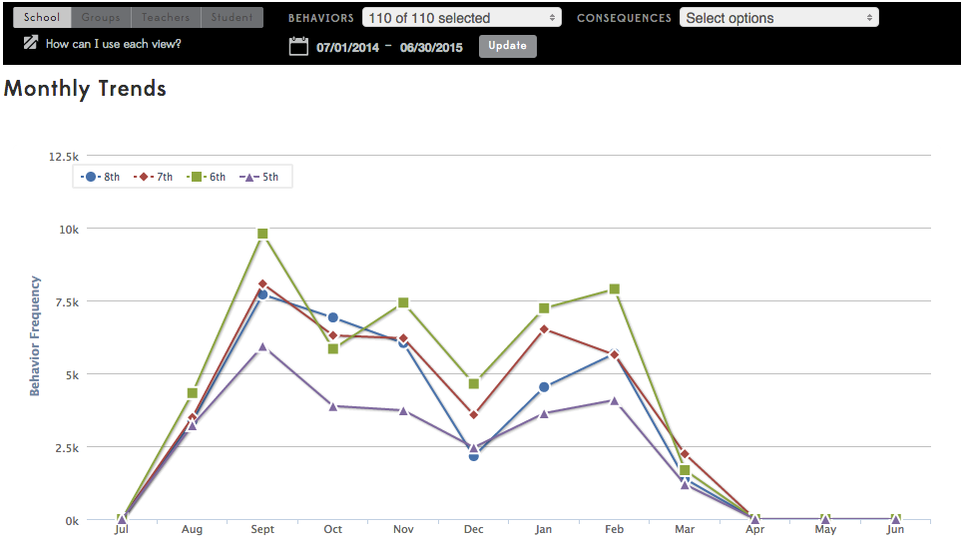  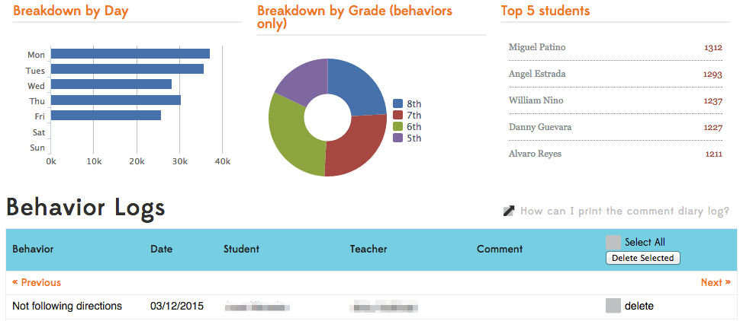

HELP RESOURCES
Learn More at the Kickboard University (KBU) Knowledgebase  Click on the Question Mark (?)  Select any listed question or select “Explore the Knowledgebase”  Scroll through the listed categories or type what you are looking for in the search box | 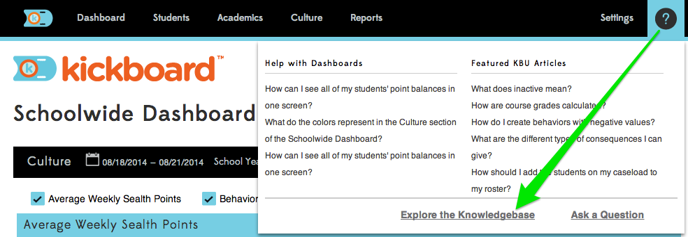  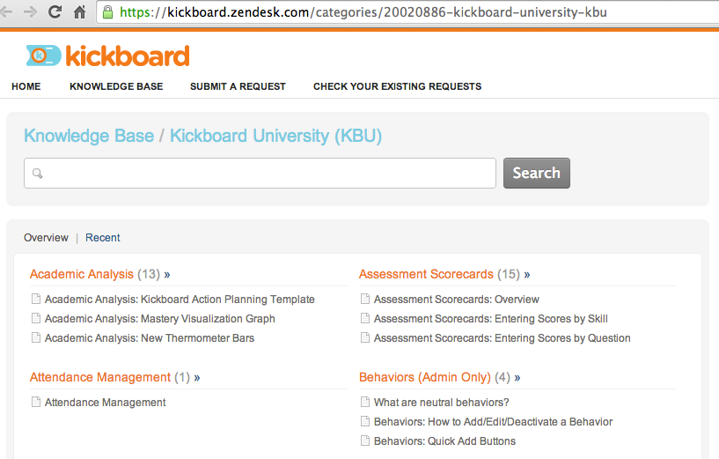
Get Help  Click on the Question Mark (?)  Select “Ask a Question”  Enter your email address  Type your question  Click “Email Us”  You can also email directly to support@kickboardforteachers.com | 